Communications Infrastructure and Services Availability in Australia 2006–07
© Commonwealth of Australia 2007
This work is copyright. Apart from any use as permitted under the Copyright Act 1968, no part may be reproduced by any process without prior written permission from the Commonwealth. Requests and inquiries concerning reproduction and rights should be addressed to the Manager, Communications and Publishing, Australian Communications and Media Authority, PO Box 13112 Law Courts, Melbourne Vic 8010.
ISBN 0 642 78353 5
Published by the Australian Communications and Media Authority
Canberra Central Office  Purple Building, Benjamin Offices  Chan Street, Belconnen  PO Box 78,  Belconnen ACT 2616  Tel: 02 6219 5555  Fax: 02 6219 5200 | Melbourne Central Office  Level 44, Melbourne Central Tower  360 Elizabeth Street, Melbourne  PO Box 13112 Law Courts  Melbourne Vic 8010  Tel: 03 9963 6800  Fax: 03 9963 6899  TTY: 03 9963 6948 | Sydney Central Office  Level 15, Tower 1 Darling Park  201 Sussex Street, Sydney  PO Box Q500  Queen Victoria Building NSW 1230  Tel: 02 9334 7700, 1800 226 667  Fax: 02 9334 7799

Contents
Introduction 1
About this report 1
Information and sources 1
Feedback 2
Executive summary 3
Chapter 1 – Broadband services 4
DSL 4
ADSL2+ infrastructure 5
Hybrid fibre coaxial cable 9
Wireless broadband 9
Satellite broadband 10
Broadband over power line 10
Optical fibre developments 11
Backhaul transmission networks 11
Government programs to improve broadband availability 12
Internet take-up 16
Broadband 16
Subscriber split – broadband and dial-up 16
Subscribers and speeds 16
Chapter 2 – Mobile voice and data services 18
Mobile telecommunications infrastructure 18
GSM mobile networks 18
CDMA mobile networks 18
3G mobile networks 21
Hutchison 21
Optus 21
Telstra 22
Vodafone 22
Mobile Take-up 22
Chapter 3 – Fixed voice services 25
Fixed voice availability and take-up 25
Universal service obligation 25
Residential and small business VoIP service providers 25
Internet service providers providing fixed voice services 27
PSTN market 27
Satellite voice 27
Payphones 28
Chapter 4 – Broadcast services 30
Commercial television services 30
National television services 30
Digital television 30
Subscription television services 31
Community television services 31
Commercial radio services 33
National radio services 33
Community radio services 35
Narrowcasting 35
Datacasting 35
Appendix A: Basic network architecture 36
Telecommunications local access networks 36
Copper wires 37
Optical fibre 37
Glossary 38

Introduction

About this report
This is a joint report issued by the Australian Communications and Media Authority (ACMA) and the Australian Competition and Consumer Commission (ACCC). The report provides an update to ACMA’s Communications Services Availability in Australia 2005–06 report, and the ACCC’s Telecommunications Infrastructure in Australia 2004.
ACMA and the ACCC have issued a joint report as part of a program of cooperation to minimise overlap in information collection and reporting between the two agencies. In the case of the ACCC, a survey had been issued in previous years to inform the drafting of its Infrastructure report. As a tangible example of the commitment of both agencies to minimising regulatory burdens where possible and appropriate, a survey has not been issued for this report. Future reports may rely on information obtained as a result of the ACCC’s proposed audit of telecommunications infrastructure, subject to the consideration of issues of commercial confidentiality.
The examination of infrastructure and service take-up undertaken in this report is intended to provide an overview of infrastructure and service availability across Australia in residential and small business retail markets. As the ACCC’s reporting series: Telecommunications Competitive Safeguards and the Changes in the Prices Paid for Telecommunications Services considers the issue of pricing, this is not analysed in this report.
Maps included in this report use colour to demonstrate the geographic availability of infrastructure and service provision. It is recommended that this report should be printed in full colour to enable coverage maps to be correctly interpreted. Grey-scale printing may make it difficult to interpret these maps accurately. Alternatively, maps may be viewed on a computer screen to assist correct interpretation.

Information and sources
Information was obtained directly from major telecommunications carriers and carriage service providers (CSPs) on the service types and geographic areas served by them as part of an annual data request by ACMA (referred to as the ‘ACMA data request’ throughout the report). Those carriers and CSPs were selected to participate in the data collection arrangements on the basis that they provide networks that supply access to fixed voice, payphone, mobile or data services.
Other primary sources of data included:
- carrier licensing and numbering allocation information available to ACMA;
- the Australian Bureau of Statistics (ABS) internet activity in Australia survey;
- publicly available information on government funding initiatives such as the Higher Bandwidth Incentive Scheme (HiBIS) and Broadband Connect; and
- news articles and media information about commercial initiatives, actions, network coverage and service take-up was obtained from publicly available sources such as company websites and public announcements.

Feedback
ACMA and the ACCC are interested in feedback from the public and welcome comments on aspects of the report, including the comprehensiveness of the information provided and the report’s style. In particular, each agency is keen to hear from service providers who may not have been included in the report and who are willing to provide information about network coverage and availability of services for future reports. Comments about the report should be sent by email to market.analysis@acma.gov.au and communications.enquiries@accc.gov.au.

Executive summary
This report provides an overview of the state of communications infrastructure and service availability in Australia.
The report identifies 19 internet service providers (ISPs) with their own network Digital Subscriber Line Access Multiplexers (DSLAMs) providing services to end-users, up from nine ISPs identified in 2004–05. These deployments are primarily driven by ISPs seeking to differentiate their services from the resale of Telstra Wholesale services. The scope and scale of these deployments is creating infrastructure competition and new wholesale opportunities outside of Telstra Wholesale’s provision of internet services. Many of the ISPs identified in ACMA’s Communications Services Availability in Australia 2005–06 report continue to expand the coverage of their networks.
There has been growth in the number of ADSL-enabled exchanges across Australia, with 323 additional exchanges enabled between 30 June 2006 and 31 January 2007. Increased availability of ADSL2+ services has emerged in non-metropolitan areas, with 88 non-metropolitan exchanges identified in January 2007 compared with 22 in June 2006.
Network deployments are helping to provide greater bandwidth to Australian broadband users, with many ISPs deploying ADSL2+ broadband services technically capable of delivering up to 24 megabits per second (Mbit/s) to end users.
Wireless broadband services continue to play an important role in providing broadband services to Australian consumers, with 204 companies providing wireless services in Australia, and more than half of these companies providing services to regional areas.
There are 6.6 million internet subscribers in Australia—3.9 million using broadband and 2.7 million dial-up subscribers.
The report notes the actions of third generation (3G) mobile carriers to upgrade the bandwidth capabilities of their networks, with each mobile carrier now having implemented the high speed downlink packet access (HSDPA) protocol to provide improved mobile data services.
In the fixed voice market, this report identifies 369 voice telephony service providers operating in Australia, with 166 companies offering services over the public switched telecommunications network (PSTN), 242 companies offering voice over internet protocol (VoIP) services, and 74 companies providing both PSTN and VoIP services.Around 18 per cent of ISPs are offering VoIP services as part of bundled broadband service offers. Appendix A contains a description of telecommunications local access networks.

Chapter 1 – Broadband services
Australian consumers have access to a range of broadband access technologies, including digital subscriber line (DSL), hybrid fibre coaxial, wireless, satellite and optical fibre services. The availability of these services depends upon a consumer’s geographic location. This chapter discusses the availability of broadband access technologies, the rollout of new broadband infrastructure, and consumer take-up of broadband services.

DSL
According to the ABS, 78 per cent of Australian broadband subscribers use DSL services, which use an existing copper pair to the customer’s premises to provide a broadband service. This report identifies 19 ISPs that have invested in their own DSLAM infrastructure to enable DSL services, with most of these ISPs providing ADSL2+ services to their customers.
ISPs have begun rolling out their own DSLAM infrastructure rather than reselling Telstra Wholesale’s broadband services, which have restrictions on service offerings, pricing and bandwidth delivery. Some ISPs claim cost benefits from installing their own DSLAM infrastructure, because it allows greater control over costs and potentially higher earning margins per customer. Network deployments may also lead to additional revenue streams through provision of wholesale services to other ISPs.
Installation of DSLAM infrastructure in local exchanges is made possible through the Australian Competition and Consumer Commission (ACCC) declaration of the unconditioned local loop (ULL) in 1999, and of the line-sharing service (LSS) in 2002. The ULL access declaration allows ISPs to provide their own telecommunications services over Telstra’s fixed copper ‘last mile’ network, by installing their infrastructure within local exchanges (typically to provide broadband and voice services). The LSS access declaration also allows for the installation of infrastructure, but the ISP shares the last mile network, with Telstra continuing to provide voice services and the ISP providing broadband services simultaneously on the same copper pair.
Table 1: Internet service providers with DSLAM infrastructure
Service providers with own DSLAM infrastructure | DSL-enabled exchanges  30 June 2006* | DSL-enabled exchanges  31 January 2007*
AAPT | 22 | 22
Adam Internet | 25 | 29
Amcom | 34 | 34
iiNet | 245 | 266
Internode/Agile | 47 | 73
Netspace Networks | na | 20
Nextep | na | 95
Onthenet | 8 | 8
Optus | 100 | 304
PowerTel | 126 | 130
Primus | 182 | 182
Regional Internet Australia** | 6 | 6
Soul | na | 22
Telstra | 2,109 | 2,432
TPG | 65 | 145
TransACT | na | 9
TSN Internet | 4 | 4
Wideband networks | 1 | 2
Widelinx | na | 3
Source: service provider websites and ACMA targeted data request
*In many cases, multiple carriers have DSL available from the same exchange – therefore, the figures should not be added to infer a total number of exchanges with DSLAM infrastructure.
** Regional Internet Australia was placed in administration in April 2007.
na: not available
At 31 January 2007, there were 2,432 exchanges providing ADSL service coverage to 91 per cent of the Australian population. Up until November 2006, Telstra restricted the speed of its ADSL-1 services to a maximum download speed of 1.5 Mbit/s, to provide ‘bandwidth consistency’ to its retail and wholesale customers. However, these restrictions have now been lifted to enable ADSL-1 services to provide up to 8 Mbit/s.
Figure 2 shows ADSL-enabled exchanges around Australia, and the number of competing infrastructure providers at each exchange (note that the map includes ADSL-1 and ADSL 2+ services). Infrastructure competition is predominantly based in the capital cities of Adelaide, Brisbane, Canberra, Melbourne, Perth and Sydney. While most exchanges are served by only one infrastructure provider, this report identifies 459 exchanges served by more than one infrastructure provider, with many consumers having access to two or more infrastructure providers.
Outside of Telstra’s DSL network, the most extensive rollouts of DSLAMs have emerged from iiNet, Optus, PowerTel, Primus and TPG. In the first quarter of 2007, iiNet had installed approximately 266 exchanges, Optus 304, PowerTel 130, Primus 182 and TPG 145.

ADSL2+ Infrastructure
ADSL2+ services can provide theoretical download speeds of up to 24 Mbit/s. At 31 January 2007, there were approximately 412 exchange locations enabled with ADSL2+, compared with 309 at 30 June 2006. ADSL2+ services are now available in 17 per cent of DSL-enabled exchanges (at January 2007), up from 14 per cent in June 2006, and 57 per cent of ADSL-enabled exchanges in metropolitan areas are now providing ADSL2+ services (compared with 53 per cent at 30 June 2006). Most of the growth in ADSL2+ services has emerged in non-metropolitan areas, with 88 non-metropolitan exchanges identified in January 2007 compared with 22 in June 2006. ADSL2+ services are available in regional centres including Dubbo, Horsham, Newcastle, Port Augusta, Townsville and Traralgon.
Table 2 displays the availability and number of competing DSLAM infrastructure providers at exchange locations. While there has been a steady rise in the number of exchange locations with two or three infrastructure providers, the greatest increase has been identified at exchange locations with five or more infrastructure providers (rising from 66 to 154 exchanges since June 2006).
Table 2: Number of DSLAM infrastructure providers by number of DSL-enabled exchanges (includes ADSL and ADSL2+ enabled exchanges)
Number of infrastructure providers | Number of exchanges  30 June 2006 | Number of exchanges  31 January 2007
1 infrastructure provider | 1,800 | 1,973
2 infrastructure providers | 115 | 163
3 infrastructure providers | 61 | 80
4 infrastructure providers | 67 | 62
5 or more infrastructure providers | 66 | 154
Source: service provider websites and ACMA data request to targeted ISPs
Figure 1: Number of ADSL and ADSL2+ enabled exchanges, 31 January 2007
Source: service provider websites and ACMA data request to targeted ISPs
Metropolitan and non-metropolitan breakdown based on Telstra Wholesale ADSL Enabled Exchanges report available at www.telstrawholesale.com/products/access_broadband_reports.htm
Figure 2: Availability of ADSL services (includes ADSL and ADSL2+ services), 31 January 2007
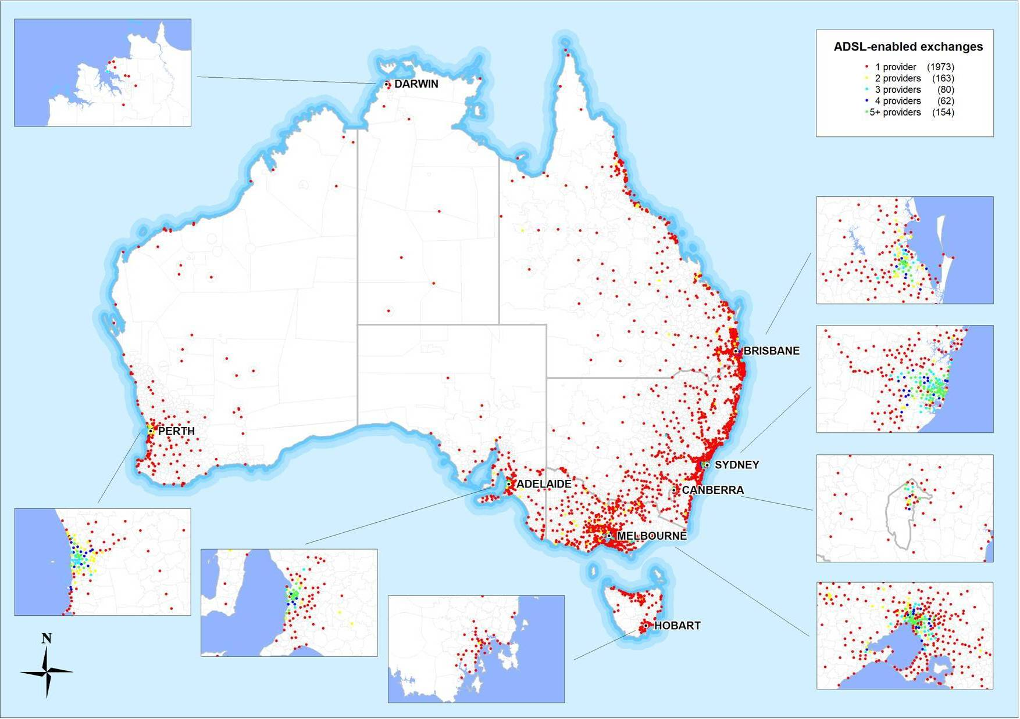
Source: service provider websites and ACMA data request to targeted ISPs
Figure 3: Availability of ADSL2+ services, 31 January 2007
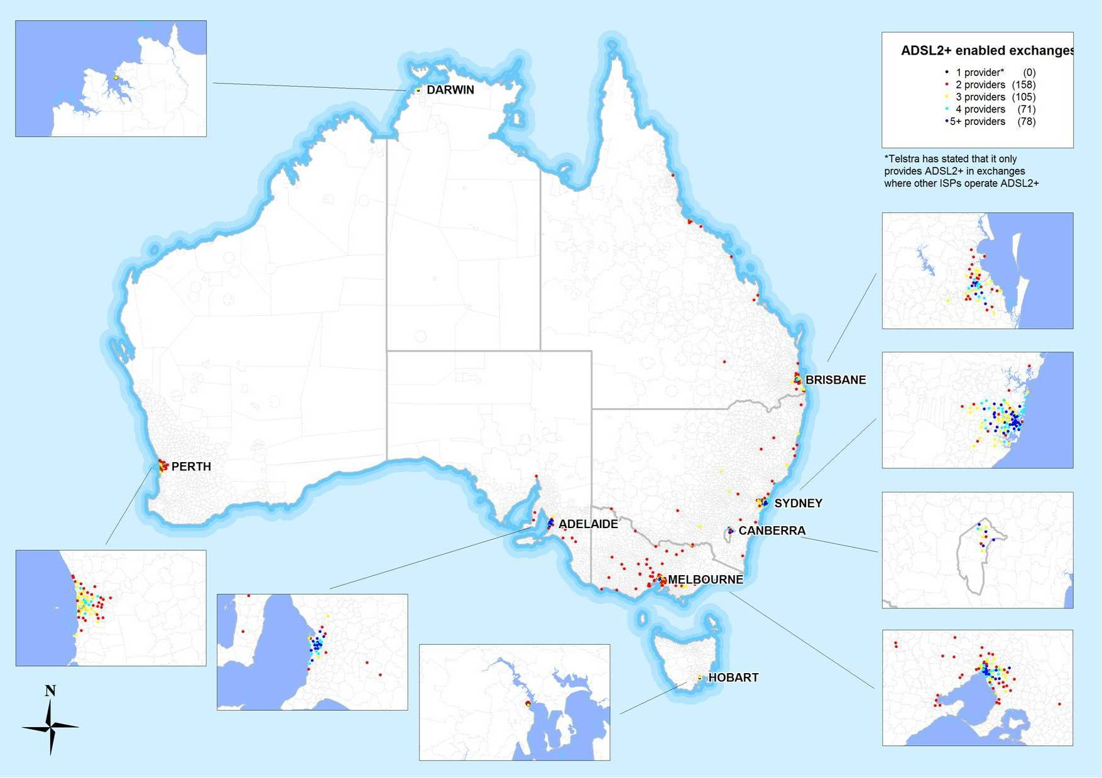
Source: service provider websites and ACMA data request to targeted ISPs

Hybrid Fibre Coaxial Cable
Hybrid fibre coaxial (HFC) cable networks, also known as ‘cable’, involve the use of optical fibre and coaxial cable capable of providing broadband access, subscription television (pay TV) and voice services. The optical fibre connection forms the ‘backbone’, with coaxial cable running from fibre nodes to the customers’ premises. Cable broadband speeds of up to 17 Mbit/s are currently offered in Australia. Internationally, testing is being carried out for significantly increased cable broadband speeds.
There are two major HFC networks in Australia, which are operated by Telstra and Optus. Telstra’s network passes 2.5 million homes in Adelaide, Brisbane, the Gold Coast, Melbourne, Perth and Sydney. Optus’ network is capable of servicing 1.4 million homes in Brisbane, Melbourne and Sydney. There is a considerable degree of overlap between these networks, resulting in an estimated combined coverage to 2.6 million homes. Telstra uses its HFC network for television and broadband services, as does Optus, which also uses HFC for voice telephony services.
In regional Victoria, Neighbourhood Cable uses its HFC network to provide broadband, pay TV and voice telephony services, high-speed data services and virtual private networks in Ballarat, Geelong and Mildura.

Wireless Broadband
Wireless broadband provides internet connectivity using a wireless ‘last mile’ to the customer’s premises. These types of services are often referred to as broadband wireless access (BWA), fixed wireless access (FWA) or wireless access services (WAS). The term ‘last mile’ may be misleading—some broadband deployers claim to be able to provide services more than 50 kilometres from the base station.
Wireless broadband services are delivered by telecommunications carriers, ISPs or other providers using a radio connection from an end-user to a core network. They use various techniques including BWA/FWA, cellular mobile networks (discussed in Chapter 2 under 3G mobile networks), wireless local loop (WLL) networks, multipoint distribution systems (MDS) and radio local area networks (RLANs). Wireless broadband can use radiofrequency spectrum between 600 MHz and 6 GHz,.
There are approximately 204 companies providing wireless services in Australia with more than half of these companies providing services to regional areas of Australia. Around five per cent of Australia’s broadband subscribers use wireless broadband services (186,000 subscribers)
Personal Broadband Australia and Unwired are two of the larger carriers that are competing with fixed-line broadband providers in metropolitan areas. Personal Broadband Australia, which operates the iBurst network, expanded its network coverage beyond Brisbane, Canberra, the Gold Coast, Melbourne and Sydney to include parts of metropolitan Adelaide and Perth in late 2006. Personal Broadband Australia does not provide direct retail access to the iBurst network, but utilises authorised iBurst service providers and retail distributors. Unwired, which focuses primarily on the residential market, provides services to the metropolitan areas of Melbourne and Sydney.
Most regional wireless broadband providers use FWA to provide broadband services. The use of a fixed antenna increases the signal strength and, consequently, the reliability of the wireless service. The main area of difference between providers is the technology used in the radio link. Many of these use class-licensed spectrum, which reduces the cost of service provision, but can affect the reliability of the service when multiple providers are operating class-licensed services in the same location.
Figure 4: Fixed wireless access

Satellite Broadband
Satellite broadband services provide 100 per cent coverage of Australia’s land area. In April 2007, there were around 41 satellite broadband service providers operating in Australia, with most of these service providers being regional ISPs that resell satellite broadband to regional, rural and remote customers.
Satellite broadband services are generally only used as a last resort in rural and remote areas where alternative infrastructure is unavailable. This is because they typically require physically large infrastructure (satellite dish), and (without government funded subsidies) are more expensive compared with other broadband options.

Broadband over Power Line
Broadband over power line (BPL) is a technology that utilises existing electricity power lines for the transmission of broadband data. BPL is also known as power line telecommunications (PLT) or power line communications (PLC). BPL can be used by a carrier:
- to supply broadband services to end-users (‘access’ BPL);
- as a technology for piping of broadband within a house without additional wiring (‘in-house’ BPL); or
- by electricity companies as a mechanism to manage and control the operation of an electricity distribution network.
Some trial deployments have been conducted in Australia, where BPL is used as part of the link to the end-user. Carriers and electricity utilities deploying BPL are examining its commercial viability as a broadband access technology and are working with community stakeholders to address technical issues such as radiocommunications interference.
Some technical trials are still under way—SP Ausnet is conducting a trial in Mount Beauty in Victoria. Energy Australia and the Woomera Consortium have already conducted trials in New South Wales.
Several organisations have recently completed technical trials of BPL and are consequently running commercial pilot programs to establish the financial viability of BPL as a fully commercial access technology.
Aurora conducted trials of BPL services to approximately 500 homes in Tasmania from late 2005. Aurora has since entered into partnership with AAPT and the cooperative venture TasTel has obtained a carrier licence.
Country Energy also conducted technical BPL trials in Jerrabomberra and Queanbeyan in New South Wales and is now planning to run commercial pilots.

Optical fibre developments
Fibre-to-the-node/kerb (FTTN/FTTK) networks incorporate the installation of optical fibre to transmission equipment (such as a customer multiplexer) near to the end-user. In Canberra, TransACT Communications offers an FTTK network in which optical fibre is taken within 300 metres of the connection to the home, from which very high speed DSL (VDSL) is used to carry voice and data transmissions over copper to the customer premises. Each optical fibre cable services a small area of around 45 to 65 homes and businesses. In May 2007, TransACT announced the rollout of a fibre-to-the-home (FTTH) development in the community of Forde, which will provide download speeds up to 30 Mbit/s and 10 Mbit/s for uploads. FTTH services will be provided to more than 1,000 homes in the community by 2013.
Limited FTTH or premises schemes have been planned or commenced in several states, usually in new land developments. Some of these initiatives are being pursued by state governments. These include:
- The Queensland Government has initiated Project Vista, which plans to bring a 100 Mbit/s broadband service to Brisbane through a deployment of FTTH technology. The project is estimated to cost $550 million and is scheduled for rollout in 2008.
- The Victorian Government has developed the Aurora project, which aims to deliver FTTH broadband services to approximately 8,000 residents in the Aurora estate in Melbourne’s northern suburbs. Residents will be offered voice telephony, data and video services over the network, including pay TV, free-to-air television and the emerging video-on-demand (VOD) services.
- The Tasmanian Government is pursuing the TasCOLT project, which is a pilot project with aerial fibre cabling using new-generation passive optical networking technology.

Backhaul Transmission Networks
Backhaul refers to the medium and long distance optical fibre and microwave transmission networks that connect local exchanges, main exchanges and mobile and fixed wireless towers between all population centres in Australia. Backhaul networks carry voice and data transmissions.
Telstra and Optus operate substantial backhaul transmission networks. Other providers, including Nextgen, PIPE Networks, Powertel, Silk Telecom and Soul operate backhaul networks in metropolitan and regional areas across Australia. While some routes are served by three or more operators, the majority are served by Telstra alone.
The economics of rolling out fixed network infrastructure to regional areas is influenced by demand characteristics and the distances involved. This leads to infrastructure costs generally being more expensive than comparable network infrastructure in Australia’s major capital cities, which is the case not only in Australia but in many countries around the world.

Government Programs to Improve Broadband Availability
The Australian Government has implemented several initiatives to improve the availability of telecommunications services in Australia.
Higher Bandwidth Incentive Scheme
HiBIS was a $157.8 million scheme providing registered ISPs with incentive payments to supply higher bandwidth services in regional, rural and remote areas at prices comparable to those available in metropolitan areas. It was part of the government contribution to the National Broadband Strategy and was developed in response to recommendation 6.3 of the report of the 2002 Regional Telecommunications Inquiry.
Broadband Connect
The HiBIS program was replaced with the Broadband Connect program from 1 January 2006. Figure 5 shows areas where the HiBIS and Broadband Connect programs have contributed towards wireless broadband coverage. Figure 6 shows exchanges that were ADSL-enabled through private investment and those enabled with assistance from the HiBIS and Broadband Connect programs, which have contributed towards fixed-line broadband coverage.
Australian Broadband Guarantee
The Australian Broadband Guarantee announced in March 2007 will ensure subsidised internet access for Australians currently unable to gain a reasonable level of broadband service at their principal place of residence or small business. The government has indicated that, for consumers, it will be very similar to the previous Broadband Connect program, funding provision of subsidised, price-capped broadband at a guaranteed minimum level of service to eligible consumers, but with the benefit of simpler eligibility requirements. The first phase of the Australian Broadband Guarantee will run until June 2008, when the funds from the $2 billion Communications Fund will come on stream.
The Australian Broadband Guarantee is part of the transition to the Broadband Connect Infrastructure Program. The infrastructure program is intended to establish an efficient, sustainable broadband infrastructure base across regional Australia to enable the rollout of higher speed broadband.

Clever Networks
The government is also funding the $113 million Clever Networks program, which supports specialist broadband services to communities in regional, rural and remote Australia. Sixteen preferred projects have been selected in the first round of the Innovative Services Delivery element. These projects will use broadband to improve service delivery in the areas of health, education, government and emergency services for communities in rural and regional Australia.
Figure 5: HiBIS and Broadband Connect-subsidised wireless broadband service, 31 January 2007 (includes actual and planned coverage)
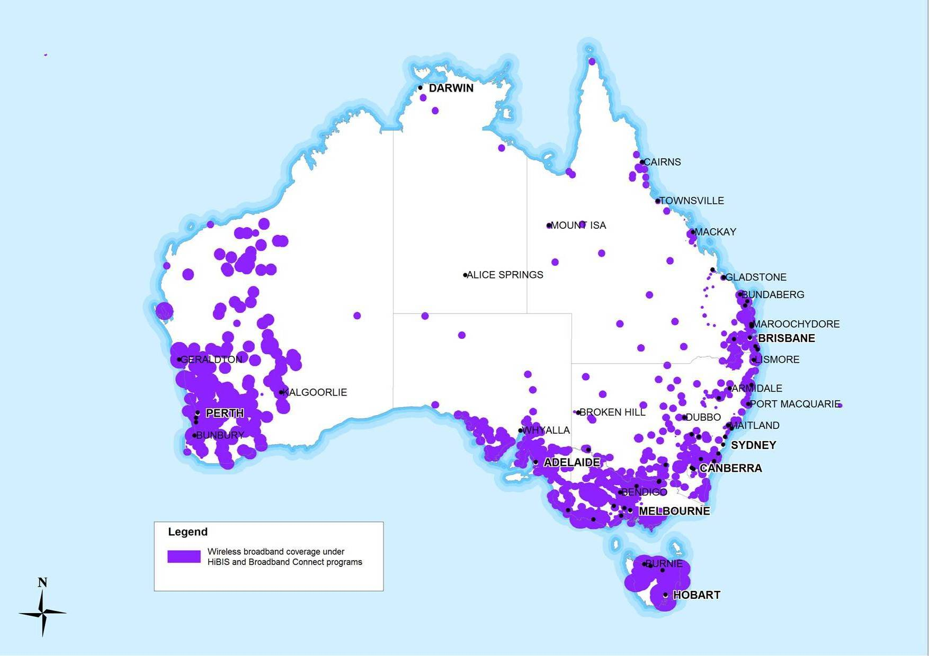
Source: DCITA HiBIS and Broadband Connect data. Note: coverage is indicative only and is not universally available in all locations identified.
Figure 6: HiBIS/Broadband Connect-subsidised ADSL enabled exchanges, January 31 2007
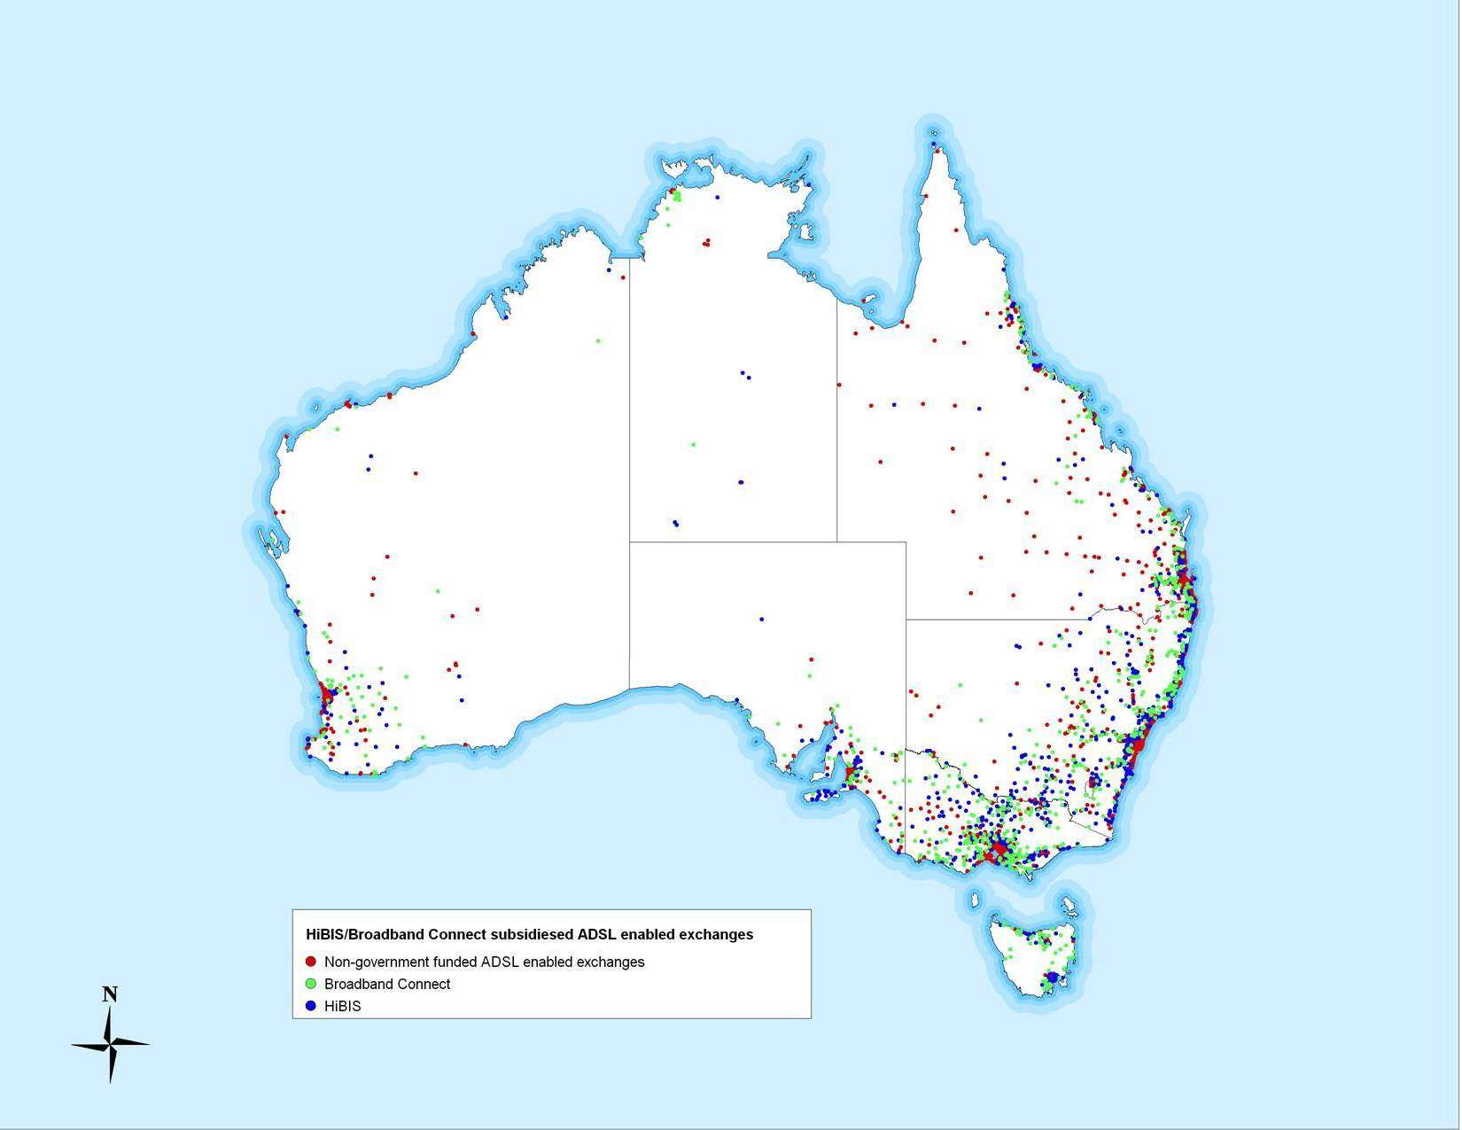
Source: www.telstrawholesale.com

Internet take-up

Broadband
Australia is similar to the majority of OECD countries in that DSL is the most commonly used form of broadband infrastructure—almost 78 per cent of broadband subscribers connect via DSL. To the extent that Australia is more reliant on DSL, this is readily explicable by the fact that the use of cable infrastructure is more limited than the OECD average.

Subscriber split – broadband and dial-up
According to the ABS internet activity survey for March 2007, there were around 6,429,000 active internet subscribers in Australia at the end of March 2007, comprised of 5,668,000 household subscribers and 761,000 business and government subscribers. Broadband subscribers comprise 67 per cent (4,331,000) of all internet subscribers in Australia.

Subscribers and speeds
According to Roy Morgan Single Source data (April–June 2006 quarter), the most common use of the internet was for applications not requiring high levels of bandwidth—email, followed by web browsing, online banking, bill payment and downloading music. The majority of household subscribers in Australia have broadband plans that provide access to download speeds of less than 512 kbit/s, which is sufficient for these common applications. However, as highlighted by Table 4, nearly a quarter of all internet subscribers access speeds of 1.5 Mbit/s or greater. As part of its consumer research program, ACMA intends to examine the factors affecting consumer choices in this area.
Table 3: Internet subscribers by bandwidth of connection: household and business/government
Household subscribers | No. of subscribers (’000s) | %
Less than 256 kbit/s | 1,848 | 33
256 kbit/s to less than 512 kbit/s | 1,240 | 22
512 kbit/s to less than 1.5 Mbit/s | 1,186 | 21
1.5 Mbit/s or greater | 1,394 | 24
Total (all access speeds) | 5,668 | 100
Business and government subscribers | No. of subscribers (000s) | %
Less than 256 kit/s | 249 | 33
256 kbit/s to less than 512 kbit/s | 160 | 21
512 kbit/s to less than 1.5 Mbit/s | 190 | 25
1.5 Mbit/s or greater | 162 | 21
Total all access speeds | 761 | 100
Source: ABS, 8153.0 – Internet Activity, Australia, Mar 2007
Overall, when subscribers are viewed in total, download speeds accessed remain relatively similar, as Table 4 illustrates.
Table 4: Internet subscribers by bandwidth of connection: total
Total internet subscribers – household and business/government | No. of subs (000s) | %
Less than 256 kbit/s | 2,097 | 33
256 kbit/s to less than 512 kbit/s | 1,399 | 22
512 kbit/s to less than 1.5 Mbit/s | 1,376 | 21
1.5 Mbit/s or greater | 1,556 | 24
Total all access speeds | 6,429 | 100
Source: ABS, 8153.0 –Internet Activity, Australia, Mar 2007

Chapter 2 – Mobile voice and data services

Mobile telecommunications infrastructure
At 31 January 2007, there were four mobile carriers operating seven mobile networks. Table 5 summarises the mobile networks currently in operation.
Table 5: Mobile networks, 31 January 2007
 | Telstra | ‘3’ | Optus | Vodafone
3G | * | * | (shared infrastructure)
GSM |  |  |  | 
CDMA | 
*Note: Telstra continues to share infrastructure through its joint venture with ‘3’ and also operates its own 3G network (850 MHz)—the ‘Next G’ network—independent of the joint venture. Telstra’s CDMA network is expected to be shut down in 2008 with equivalent coverage to be provided on its Next G network.

GSM Mobile networks
GSM mobile networks are owned and operated by Optus, Telstra and Vodafone, and provide coverage to 96 per cent of the Australian population. While GSM networks were primarily designed for voice carriage, they have evolved to be able to transmit data, albeit at lower data rates than 3G networks. GSM is capable of transmitting data using technologies such as GPRS (general packet radio service) and EDGE (enhanced data rates for GSM evolution).
Telstra, Optus and Vodafone have been GPRS capable since 2002–03, and Telstra is the only carrier currently operating EDGE technology (launched in late September 2006). Telstra is reportedly extending its coverage of EDGE and is believed to be working towards increased data rates on its EDGE network.

CDMA Mobile networks
Australia’s only remaining CDMA network is operated by Telstra and is expected to be shut down in 2008 with equivalent coverage (98 per cent of the population) to be provided over Telstra’s Next G (3G) network. Telstra provides data access on its CDMA network through the CDMA 2000 1xRTT technology. Hutchison switched off its CDMA network (originally known as ‘Orange’ and later known as ‘3 CDMA’) in August 2006 and migrated customers to its 3G network.
Figure 7: Combined GSM mobile coverage (Optus, Telstra, Vodafone), 30 June 2006
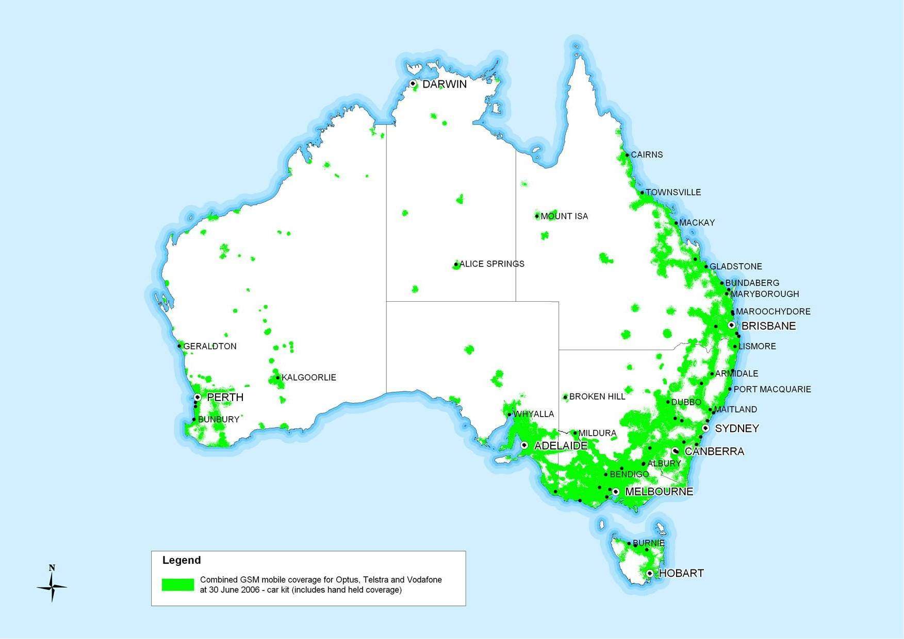
Source: ACMA data request
Figure 8: Telstra CDMA coverage, 30 June 2006
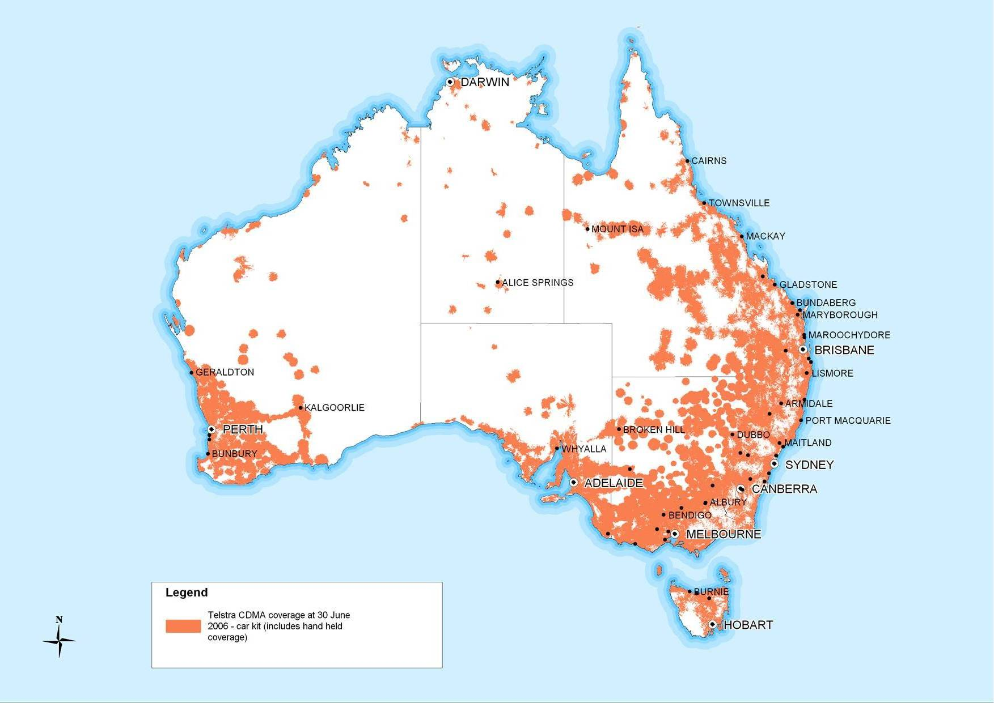
Source: ACMA data request

3G Mobile Networks
Designed to provide both voice and data services to end-users, 3G mobile networks differ from GSM and CDMA networks currently operating in Australia in that they provide higher bandwidth data services, allowing consumers access to a new range of content and applications.
These 3G networks can provide access to data and the internet through:
- a mobile handset;
- a mobile handset functioning as a modem for a laptop or personal computer (plugged into the laptop or PC); or
- a data card that is inserted into a laptop or PC.
It is important to note that the data rates quoted below refer to the maximum technical capabilities of these networks. Actual speeds will be slower, depending on the number of consumers simultaneously using the network, their distance from the base station, and radio conditions (which may be affected by terrain, buildings or other radio obstructions).

Hutchison
Hutchison was the first to offer a service using 3G technology in Australia, launching its ‘3’ service in 2003, and until 2005, was the only carrier in Australia to offer 3G mobile services. It has a 50/50 ownership arrangement with Telstra, with the two companies sharing the network, and operates in Adelaide, Brisbane, Canberra, the Gold Coast, Melbourne, Perth and Sydney.
In March 2007, the network was upgraded to the HSDPA protocol, allowing typical download speeds ranging from 600 kbit/s to 1.5 Mbit/s, with a theoretical maximum of 3.6 Mbit/s (both Telstra and ‘3’ customers have access to the improved download speeds). Hutchison has stated that it intends to make further network upgrades in 2007 when appropriate handsets and datacards are available.

Optus
Optus launched its 3G network in October 2005 in a joint infrastructure-sharing arrangement with Vodafone. The joint network covers metropolitan areas in Adelaide, Brisbane, Canberra, the Gold Coast, Melbourne, Perth and Sydney.
In January 2007, Optus announced plans to build a new 3G mobile network to extend coverage outside of Australia’s capital cities and into rural areas, replicating the coverage of Optus’ existing GSM (2G) national mobile network, which provides coverage to 96 per cent of the Australian population.
Services are expected to be available on the new network in early 2008, and network build completion scheduled for 2010. The first phase will cover areas such as Ballarat, Bendigo, Newcastle and Wollongong.
Optus will own the new network (without joint ownership by Vodafone or other partners), but will continue to jointly own and operate its existing 3G network in metropolitan areas with Vodafone. The network is expected to operate on the 2100 MHz frequency band that Optus’ existing 3G network uses. Optus has also stated that it is investigating use of 3G in the 900 MHz frequency range to address smaller regional centres as well as rural and remote locations. Lower frequency ranges give more extensive coverage across sparsely populated rural and remote areas. The new network is reported to initially provide speeds of up to 3.6 Mbit/s using the HSDPA protocol, with an eventual upgrade to 14.4 Mbit/s planned.

Telstra
Telstra currently operates two separate 3G networks, the network jointly owned with Hutchison and its Next G network. Telstra launched its Next G network in October 2006. The network initially provided coverage to 98 per cent of the Australian population, and Telstra claims coverage now reaches 98.8 per cent of the population, covering 1.9 million square kilometres. In April 2007, Telstra claimed its Next G network was capable of providing network speeds of up to 14.4 Mbit/s in the downlink and 1.9 Mbit/s in the uplink. Telstra is not currently offering wholesale services to other CSPs over the Next G network.

Vodafone
Vodafone launched its 3G network in October 2005 in a joint infrastructure-sharing arrangement with Optus. The joint network covers metropolitan areas in Adelaide, Brisbane, Canberra, the Gold Coast, Melbourne, Perth and Sydney. In October 2006, Vodafone announced that it had switched on HSDPA on the network, increasing download speeds to Vodafone customers up to 1.8 Mbit/s (up from 384 kbit/s).

Mobile Take-up
Table 6 demonstrates the extent of penetration that mobile telephony has achieved in the Australian market. The number of mobile services in operation grew by seven per cent in 2005–06 to 19.7 million.
Table 6: Mobile take-up
Type of network | Mobile services at 30 June 2006
GSM | 15.5 million
CDMA | 1.8 million
3G | 1.6 million
Total retail | 18.9 million
Wholesale (combined GSM, CDMA, 3G) | 0.8 million
Total mobile services | 19.7 million
Source: ACMA data request
As consumers increasingly move from GSM to 3G technology they are also exposed to a wider range of data services. There has been a significant expansion in data applications beyond the short message service (SMS), which is still used by consumers. As mobile handset technology has developed, devices have been able to perform a wider range of functions, such as photography, and sound and video recording, including transmitting these in a data format—known as multi-media messaging (MMS) service. The delineation between SMS and MMS reflects the amount of data (bits) required to transmit the intended information.
With the investment in 3G technology, and in particular in HSDPA, data can be transmitted much faster, allowing more detailed information to be communicated to mobile handsets, including the ability to browse the internet and view video images. Most service providers allow users access to a variety of content including news, sports and entertainment.
In September 2006, the Minister for Communications, Information Technology and the Arts announced plans for the auction of two bands of unassigned spectrum for an expanded range of services. The first channel (known as Channel A) is intended for new free-to-air in-home digital services including datacasting, open narrowcasting or community television broadcasts. The second channel (Channel B) is intended for a wider range of services, which could include mobile television services.
Compared with current 3G video streamed over mobile phone networks, mobile television offers much more in terms of bandwidth capacity. There are two basic means of delivering content to mobile devices:
- ‘uni-casting’ where one signal is sent via one path to one individual—how video content is currently delivered to mobile phones by mobile network operators; or
- ‘multi-casting’ where one signal is sent through multiple paths to multiple devices.
In terms of network performance, uni-casting is considered much less efficient (and potentially harmful to 3G mobile networks, which can become congested). However, the allocation of the unassigned licence for mobile television spectrum is the first significant opportunity for the development of a multi-cast service.
Figure 9: 3G mobile coverage 30 June 2006 and expected coverage of Telstra 3G services prior to CDMA network closure
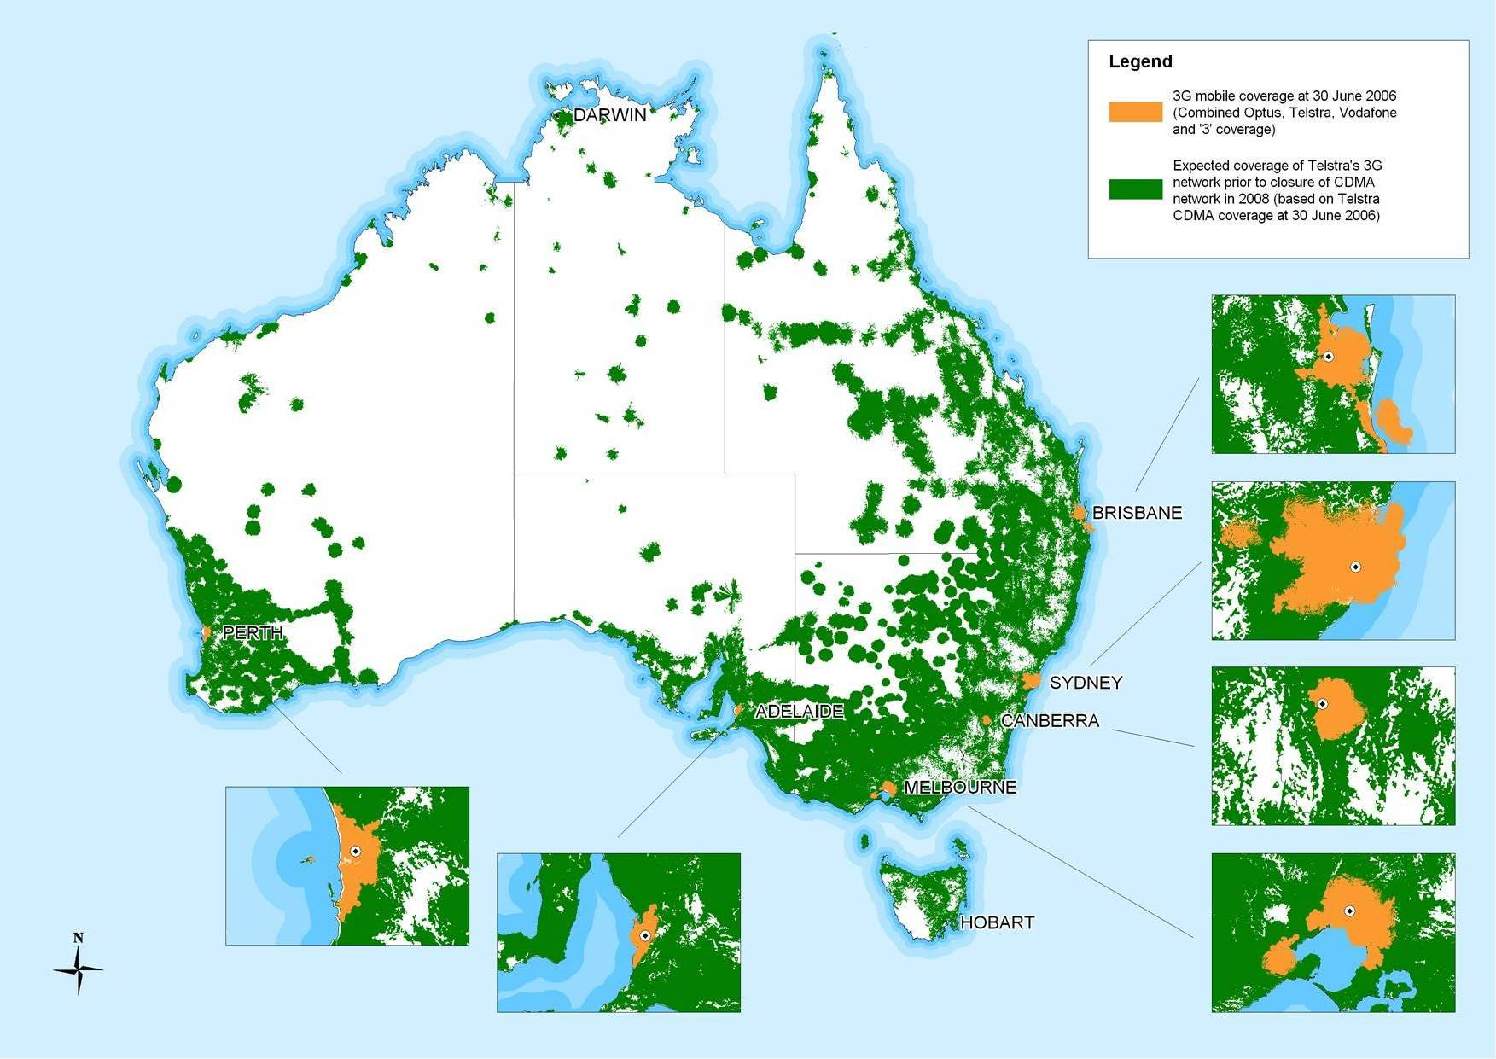
Source: ACMA data request

Chapter 3 – Fixed voice services

Fixed voice availability and take-up
It is estimated that there are approximately 369 voice service providers operating in Australia. Of these, 166 are offering services over the conventional fixed-line network (PSTN) and 242 are offering VoIP-based services (with 74 companies providing both PSTN and VoIP services).

Universal Service Obligation
The universal service obligation (USO) requires Telstra to ensure standard telephone services are reasonably accessible to all people in Australia on an equitable basis, wherever they reside or carry on business. While the USO is generally supplied on a fixed-line standard telephone service, it may be provided by other means, for example, by a mobile, satellite or wireless local loop service.
EXTENDED ZONES
The extended zones agreement is a $150 million contract between the Commonwealth and Telstra for the provision of improved telecommunications services to customers living in the Telstra extended charging zones, which are located in the remotest parts of Australia. Under the agreement, which commenced in July 2001 and operates for a period of 10 years, Telstra is required to provide:
- untimed calls at the local call rate in the extended zones;
- enhanced services, including the offer of an always-on internet access service, improved dial-up access speeds and improved timeframes for the connection of new services in the extended zones; and
- an upgrade of the telephone network in the extended zones.
Figure 10 shows those areas covered by the extended zones agreement between the Commonwealth and Telstra.

Residential and Small Business VoIP Service Providers
One hundred and fifty-two VoIP service providers have been identified as targeting the residential consumer and small to medium business market. A small number of these companies are listed on the Australian Stock Exchange (ASX), and the information they provide to the ASX provides some insight to growth in the VoIP market.
Engin and Mynetfone are two VoIP companies publicly listed on the ASX that have reported customer take-up of their services. Engin reported that it has 58,000 paying subscriber lines, while Mynetfone reported 26,000 subscribers at 12 April 2007.
Figure 10: Extended zones of Australia
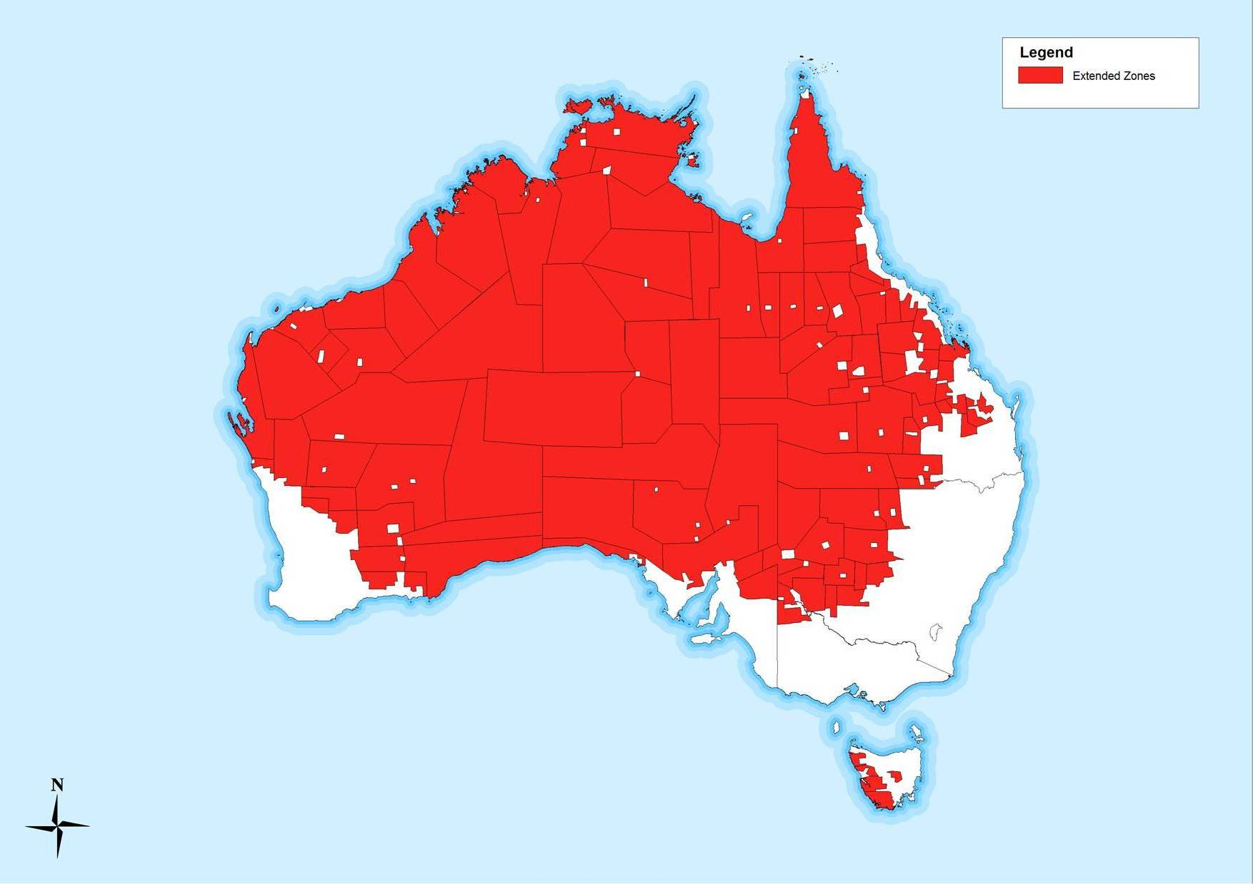
Source: DCITA

Internet Service Providers providing fixed voice services
ISPs are active in the fixed voice market, providing voice services as part of bundled broadband internet packages. In its September 2006 internet activity survey, the ABS identified 85 ISPs that provide VoIP services as part of an internet package. Table 7 shows the number of ISPs offering VoIP services as part of an internet package, classified by ISP size (number of subscribers).
Overall, 18 per cent of ISPs provide VoIP services as part of a bundled internet package to consumers, with approximately 30 per cent of large and very large ISPs providing VoIP services. This indicates that there is still room for more than 80 per cent of ISPs to provide a fixed-voice product as a bundle with their internet services. Table 7 also shows that 33 per cent of small ISPs provide VoIP services. Given their low subscriber numbers, many small ISPs may be servicing a distinct regional, rural or remote location area, providing alternative voice options in regional voice markets. ISP iiNet has reported it has 45,000 VoIP customers, with growth estimated at 4–5 per cent per month.
Table 7: ISPs providing VoIP as part of bundled service offers by size of ISP
 | Very small (1–100 subscribers) | Small  (101–1,000 subscribers) | Medium (1,001–10,000) | Large (10,001–100,000 subscribers) | Very large (100,000+ subscribers) | No. of ISPs
Internet bundled with VoIP | 13 | 40 | 22 | 7 | 3 | 85
Total ISPs | 124 | 119 | 112 | 22 | 10 | 467
% of ISPs offering VoIP | 10 | 33 | 19 | 31 | 30 | 18
Source: ABS, 8153.0 Internet Activity, Australia, Sep 2006, unpublished data

PSTN Market
Based on information provided by telecommunications carriers, ACMA estimates that there were approximately 11.26 million fixed voice (standard telephone) services at 30 June 2006, compared with 11.46 million at 30 June 2005—a decrease of 1.8 per cent.

Satellite Voice
Satellite voice services are available across 100 per cent of Australia’s land area, and provide important service coverage in areas where terrestrial mobile services are unavailable. Services are provided in Australia on the GlobalStar, Inmarsat, Iridium and MobileSat satellite networks.
For consumers who regularly travel beyond mobile coverage areas, dual-mode handsets operate as mobile phones where GSM or CDMA coverage is available, and as satellite phones where there is no mobile coverage. The Australian Government’s Satellite Phone Subsidy Scheme will continue until 2009 as part of the $30 million Mobile Connect program. The scheme provides a subsidy for the purchase of a satellite phone to individuals who live outside terrestrial mobile GSM or CDMA coverage. The subsidy does not apply to ongoing billing costs that may be incurred through use of the phone.

Payphones
Table 8 shows the numbers of payphones in Australia at 30 June 2006, including Telstra-operated payphones, payphones provided by hotels, clubs and other private operators, and TriTel payphones.
Table 8: Number of payphones by service provider and type of location, June 2006
Service provider | Total | Urban | Rural | Remote
Telstra | 30,091 | 20,708 | 8,091 | 1,292
Other | 27,191 | 20,685 | 5,949 | 557
TriTel | 948 | 871 | 77 | 0
Total | 58,230 | 42,264 | 14,117 | 1,849
Source: ACMA data request
In February 2006, Telstra announced it was considering the removal of up to 5,000 public payphones that are loss-making and not required to fulfil the USO. On 8 June 2006, in response to community concern, the Minister for Communications, Information Technology and the Arts announced initiatives to ensure more consultation and better information about any Telstra plans to remove payphones from a community.
Figure 11: Telstra payphone locations
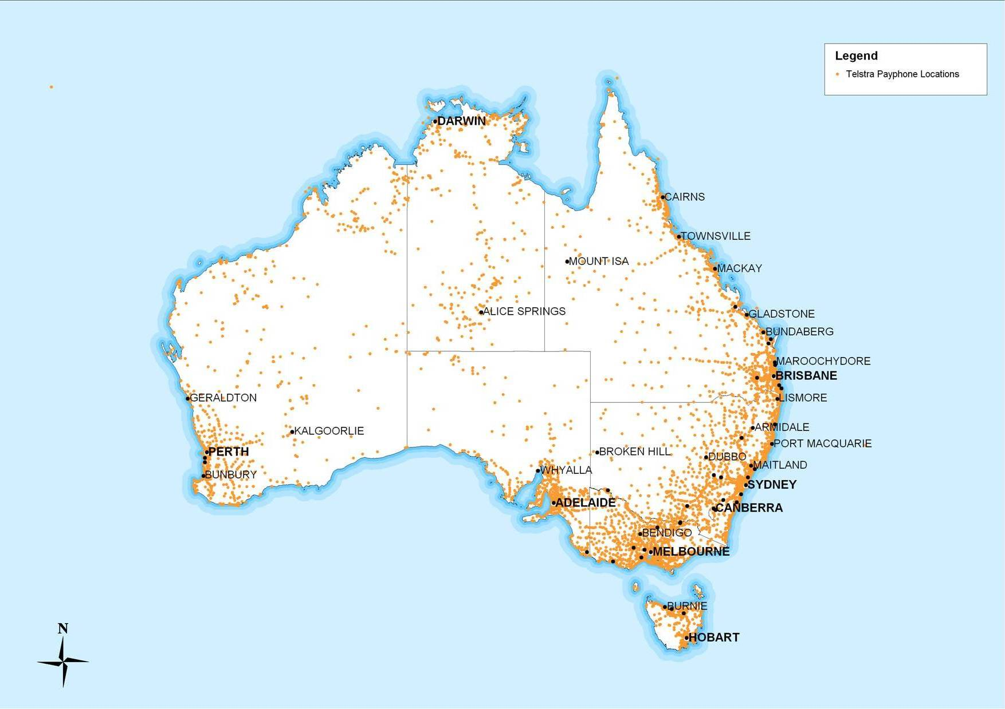
Source: ACMA data request to Telstra
Note: Multiple payphones (at separate payphone sites) may be available in locations identified on this map.

Chapter 4 – Broadcast services
Commercial television and radio services continue to have a pivotal role in the delivery of entertainment and news services to Australian consumers. Furthermore, as digital broadcasting develops further, the nature of services can be expected to expand. This chapter provides an overview of the broadcast services available to Australian consumers.

Commercial Television Services
There are 28 distinct commercial television licence areas across Australia. Broadcast planning provides for three commercial television licence operators in Adelaide, Brisbane, Melbourne, Perth and Sydney. The Seven, Nine and Ten networks operate in each of these cities. There are three licensees operating in Canberra and Hobart, and two in Darwin. In regional areas, the majority of broadcasting is provided by the NBN, Prime, Seven Queensland, Southern Cross Broadcasting and WIN networks.
Figure 11 illustrates Australia’s commercial television licence areas and the number of licensees operating in each area. Higher levels of availability tend to be concentrated in the major capital cities, and along the eastern seaboard.

National Television Services
National television broadcasting services funded by the Australian Government are provided by the Australian Broadcasting Commission (ABC) and Special Broadcasting Service (SBS). The ABC provides the following television services:
- a national free-to-air analog service available to more than 98 per cent of the Australian population;
- three digital free-to-air channels available to more than 96 per cent of the Australian population, comprising high definition and standard definition simulcasts of ABC analog and ABC 2, which features new and time-shifted ABC programming; and
- an Asia–Pacific free-to-air satellite television service (only available outside Australia).
SBS provides multilingual and multicultural television services that reach 95 per cent of the Australian population through its analog service and 80 per cent through its digital service.

Digital Television
Digital television services are currently available in all capital cities and in most major regional centres. Around 85 per cent of the population can access digital television from all of their local free-to-air broadcasters (commercial and national broadcasters), and around 96 per cent of the population has access to one free-to-air digital service. Research commissioned by ACMA in 2006 indicated that 29.6 per cent of Australian households had digital free-to-air television.
Digital television provides improved picture and sound quality, enables widescreen images, and provides extra channels and enables new features such as electronic program guides and interactivity.
In November 2006, the minister released a digital action plan for the switchover to digital television broadcasting in Australia. As part of this plan, the Australian Government will establish a dedicated digital switchover body, Digital Australia, within the Department of Communications, Information Technology and the Arts. The switchover to digital is scheduled to commence in 2010–12. The cessation of analog television transmissions will free up radiofrequency spectrum for better and more productive use.
In September 2006, the Minister for Communications, Information Technology and the Arts announced plans for the auction of two bands of unassigned spectrum for an expanded range of services. The first channel (known as Channel A) is intended for new free-to-air in-home digital services including datacasting, open narrowcasting and community television broadcasts. The second channel, (Channel B) is intended for a wider range of services, which could include mobile television services.

Subscription Television Services
At 30 June 2006, there were approximately 1.73 million pay TV subscribers compared with 1.67 million subscribers at 30 June 2005. Most of Australia’s pay TV services are supplied via Telstra and Optus’ metropolitan HFC networks. Australia’s other major pay TV supplier, Austar, offers a service to selected regional and rural areas via satellite. TransACT provides pay TV services in Canberra, and Neighbourhood Cable provides services in the Victorian regional centres of Ballarat, Geelong and Mildura.
Foxtel is the largest pay TV provider in Australia, controlling the bulk of programming through ownership or distribution agreements. It has the largest number of subscribers and the most extensive reach on its satellite networks and (Telstra’s) cable network.
Optus sells pay TV packages to its customers on its high-speed cable network operating in Brisbane, Melbourne and Sydney. As well as reselling the Foxtel channels, it provides a small selection of its own channels.
Austar provides mainly satellite services to subscribers in rural and regional centres largely across Eastern Australia, as well as Darwin and Hobart.

Community Television Services
Permanent community television services were established in Brisbane, Melbourne, Perth and Sydney in 2004, after trials of community services had been operating since 1993. At 31 January 2007, there were 83 permanent community television licences, 79 of which were remote Indigenous media services.
Figure 11: Commercial television services in Australia by licence area, January 2007
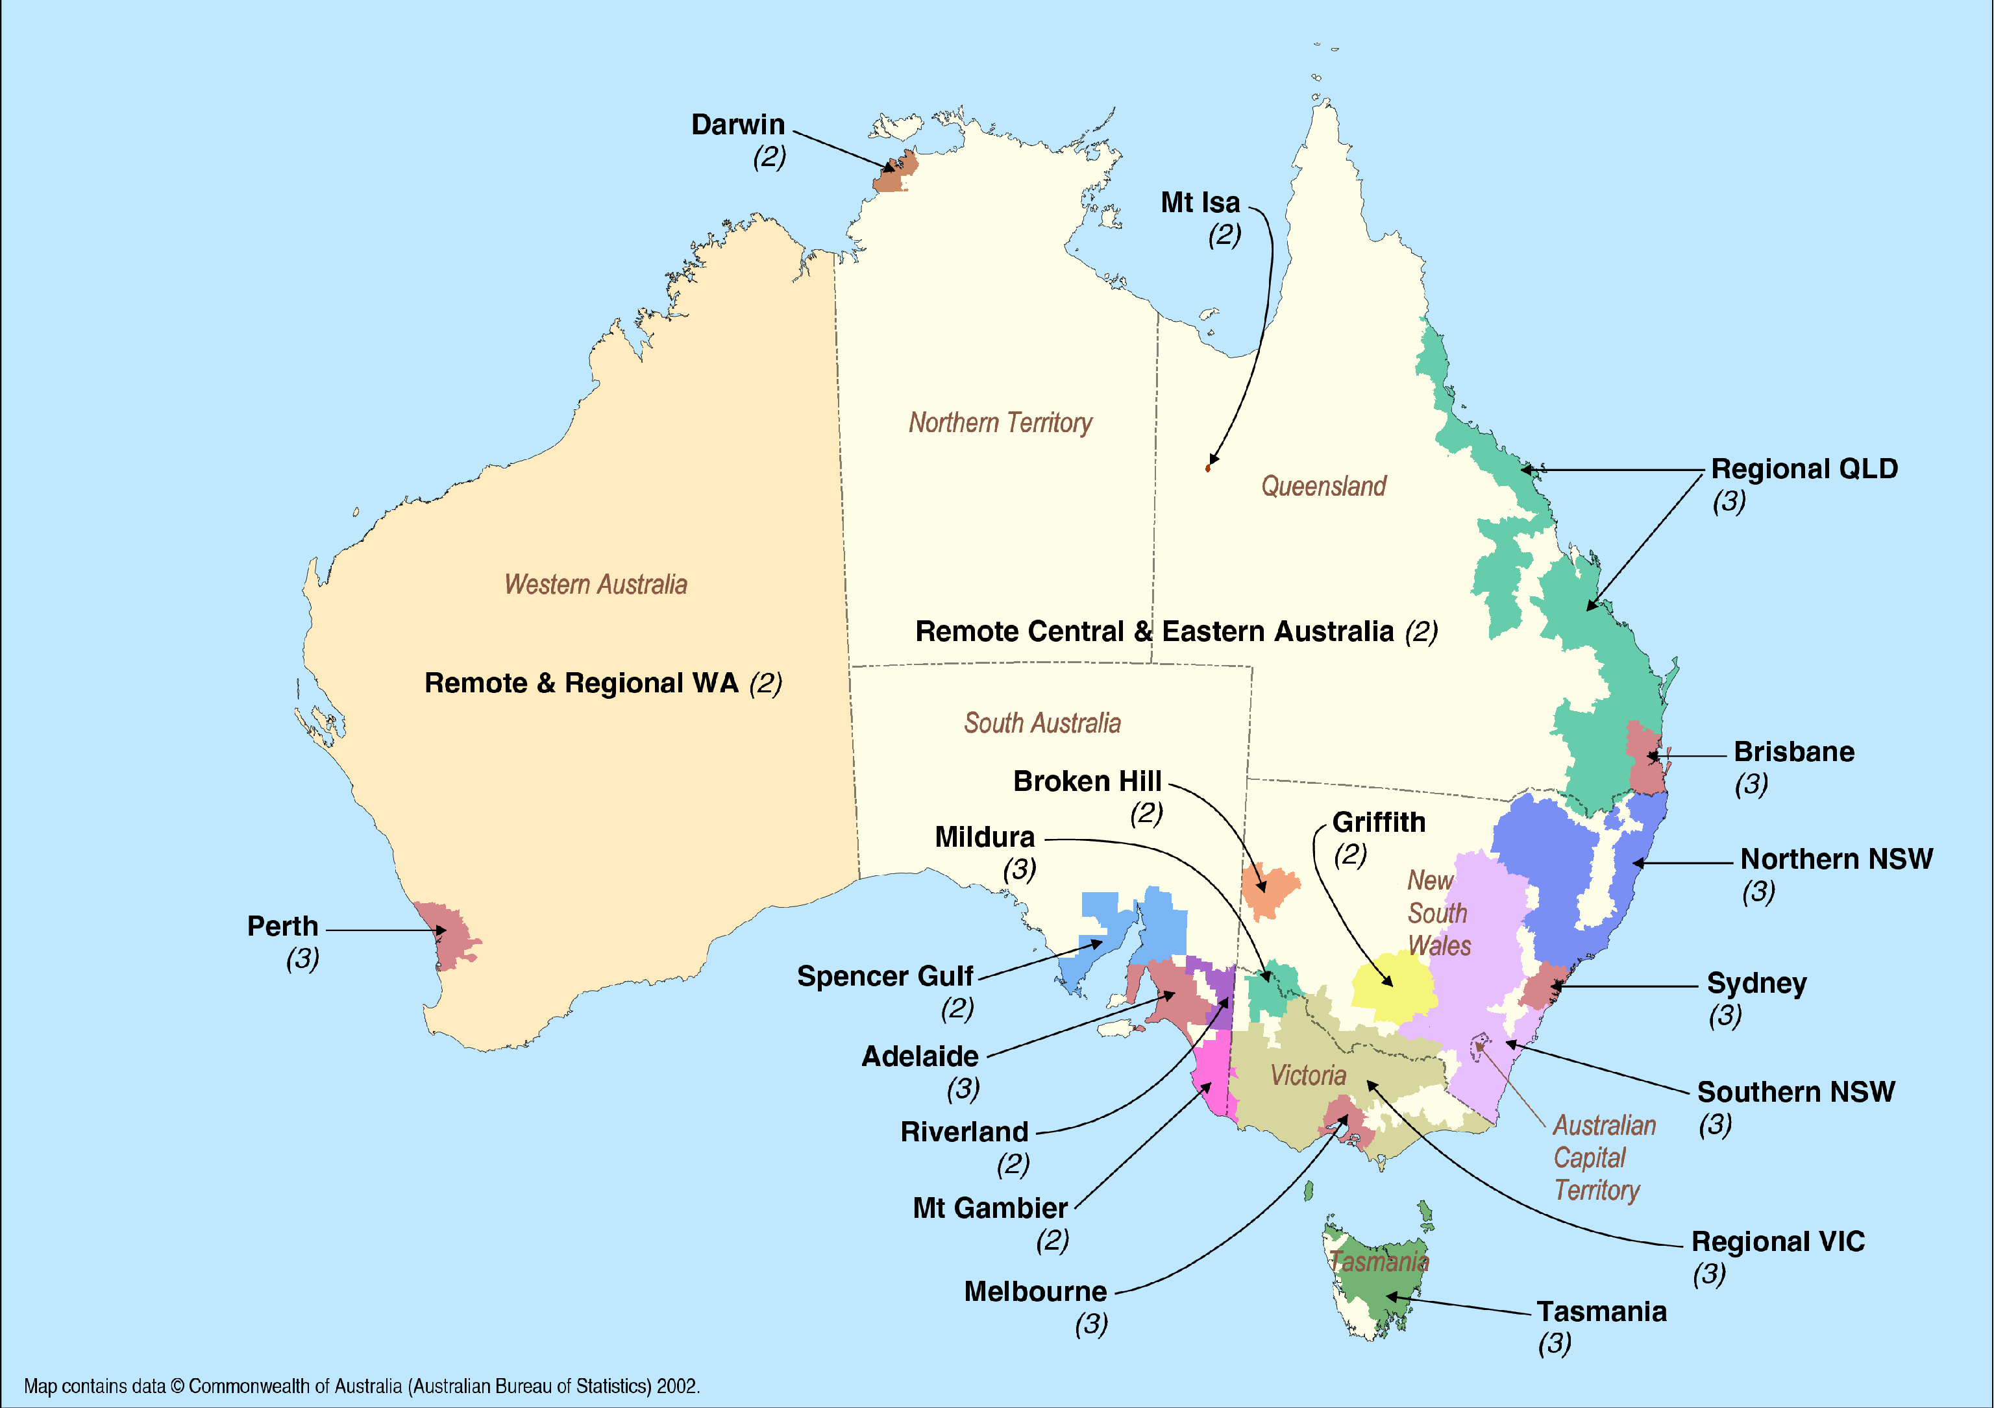
Source: ACMA

Commercial Radio Services
There are 274 commercial radio broadcasting licences in Australia, including 150 FM licences and 106 AM licences. There are also 13 non-broadcasting services band (BSB) licences, which are treated differently to licensed services within BSBs. The largest concentrations of commercial radio licences are in the major capital cities, as shown in Table 9. Most regional centres are served by two licensees, typically with one AM service and one FM service. There are four commercial radio licensees permitted to provide services Australia-wide on non-BSB frequencies.
Table 9: Number of commercial radio licences by city
City | Number of commercial licences
Sydney | 11
Melbourne | 11
Brisbane | 7
Adelaide | 6
Perth | 6
Canberra | 4
Hobart | 3
Darwin | 2
Source: ACMA licensing information
Figure 12 illustrates Australia’s commercial radio licence areas and the number of licensees operating in each area. Higher levels of availability tend to be concentrated in the major capital cities and along the eastern seaboard.

National Radio Services
The ABC provides national radio services including:
- local radio—provided on 60 stations throughout Australia;
- Radio National—national talk network;
- News Radio—national rolling news network and (when in session) broadcasts of Parliament;
- Classic FM—national classical music network;
- Triple J—national youth network; and
- Radio Australia—an Asia–Pacific network broadcasting via shortwave, satellite and online.
SBS radio broadcasts in 68 languages to all capital cities and key regional centres on a mix of FM and AM frequencies. SBS radio provides Australian and international news, homeland news, a mixture of current affairs, interviews, community information, sport and music.
Figure 12: Commercial radio services in Australia by licence area, January 2007
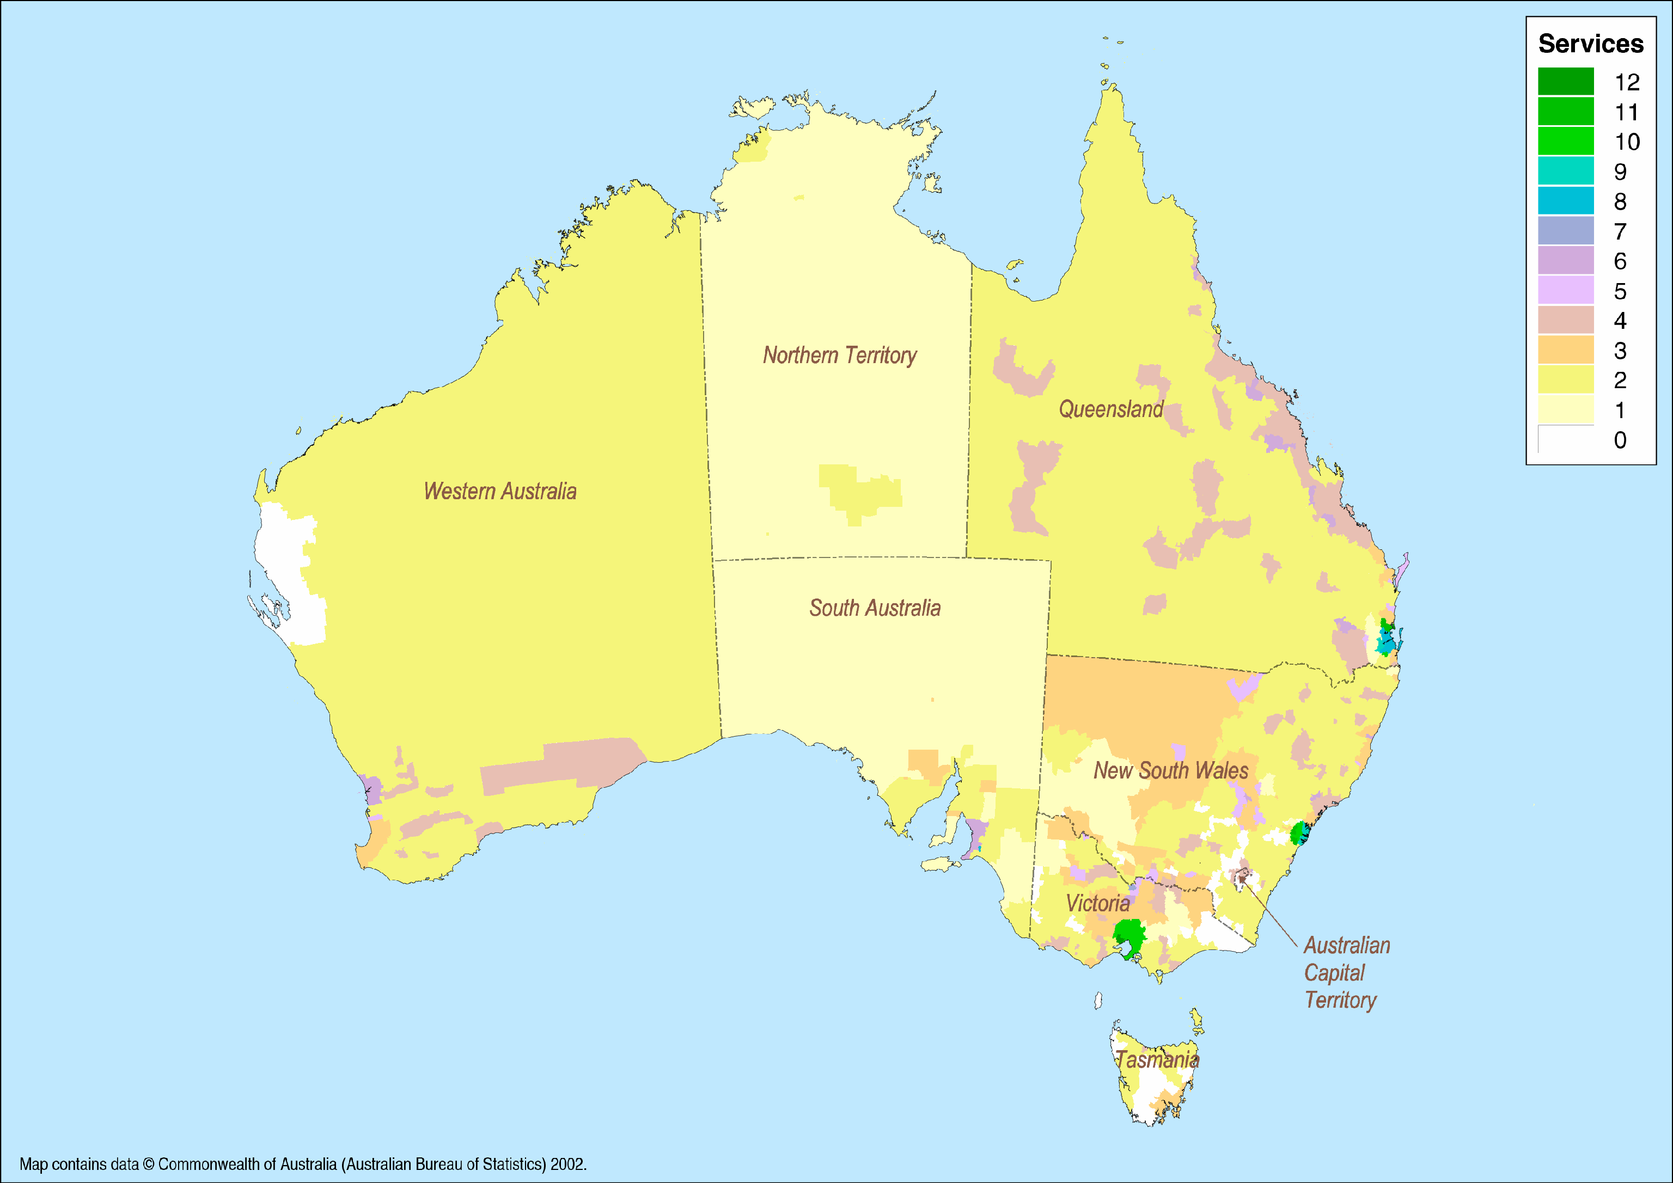
Source: ACMA

Community Radio Services
Community radio services are non-profit radio services that generally provide broadcast services to specific geographic communities or special interest groups. With 358 community radio broadcast licences issued in Australia, there are few geographical communities in Australia that do not have at least one community radio service.

Narrowcasting
An open narrowcasting service is a free-to-air broadcasting service where the reception is limited in one of the following ways:
- by being targeted to a special interest group;
- by being intended only for limited locations, for example, arenas or business premises;
- by being provided during a limited period or to cover a special event;
- because it provides programs of limited appeal; or
- for some other reason.
The most common formats provided by open narrowcasting radio services include racing information and tourist information, and non-English language, specialised music (such as dance, jazz and country music) and religious programming.
Since 1992, there have been 243 licences allocated using a price-based (auction style) system to provide high-power open narrowcasting radio services. Five licences to provide open narrowcasting television services have also been issued.
At 31 January 2007, 823 licences are currently issued to provide low-power open narrowcasting (LPON) services. LPON services have power limits that restrict transmission to limited areas and are intended for the provision of niche radio broadcasting services.

Datacasting
Datacasting is considered to be any transmission that is not a broadcasting service. Broadcasters hold datacast licences to cover the transmission of non-broadcast services, such as electronic program guides.

Appendix A: Basic network architecture

Telecommunications Local Access Networks
Traditionally, telecommunications networks are classified as either fixed or mobile, based on the degree of mobility afforded to subscribers. For instance, with a fixed network, the call must be initiated or received at the subscriber’s premises, whereas with a mobile network a call or data can be initiated or received by an individual handset at any place in which the network operates.
Generally speaking, fixed networks consist of multiple local access networks, linked together by a transmission backhaul network. Local access networks are also known as the ‘local loop’ and represent the ‘last mile’ of a fixed network.
The local access network includes the connection between each subscriber and a local network node, commonly known as an exchange or switching point, by way of particular transmission media such as copper wire, optical fibre, mobile, wireless or satellite technology. Normally, the network also includes a further transmission link from this node to a major network node that aggregates and interconnects traffic from a number of exchange or switching points, as shown in Figure 13.
The distribution media used for local access networks include:
- copper wires
- optical fibre
- HFC cable
- wireless
- mobile and
- satellite.
Factors influencing the choice of distribution media include service type, subscriber location and density, traffic volume and type, topography and legacy issues such as the technology available at the time when the network was deployed.
Figure 13: Local access network architecture
Two of the main delivery media are explained below:

Copper Wires
The largest local access network in Australia is Telstra’s customer access network (CAN), which generally uses copper-based local loops to connect subscribers to more than 5,000 local exchanges across Australia.
While Telstra also uses various microwave technologies for some backhaul and local loop transmission (particularly in regional and remote areas), optical fibre forms the basis for the backhaul network.
The copper network is the traditional means for connecting subscriber premises, and copper forms the basis of the PSTN, which is used to carry voice and data. Copper wires can be used to carry traffic at high speeds through the use of ISDN and xDSL technology at each end of the copper line.
Historically, copper access has generally been used as the predominant technology to provide the standard telephone service to Australian residential customers, and the copper access network is used by Telstra as the principal access network for delivery of the USO (see Chapter 3).

Optical fibre
Optical fibre systems use light waves for the transmission of all forms of telecommunications traffic, permitting the carriage of traffic at very high speeds with little interference. At the local access network level, it is used for transmission between network nodes and switches, and also for access to the premises of high-volume business subscribers and multi-storey office buildings.

Glossary
2G | second generation mobile telecommunications  Digital mobile telecommunications services provide voice communications and relatively low transmission rate for data (principally evolved GSM and CDMA platforms in Australia).
3G | third generation mobile telecommunications  Third generation mobile technology supports high-speed data capacities and is intended for applications other than voice. It supports applications such as full-motion video, video-conferencing and full internet access. The main standards for 3G mobile are UMTS (W-CDMA) and CDMA2000.
ADSL | asymmetric digital subscriber line  A modem technology that converts twisted-pair telephone lines into access paths for multimedia and high-speed data communications. The bit rates transmitted in both directions are different. Downstream data (data downloaded by user) transmission rate is much higher than the upstream data rate. Recent enhancements to ADSL include ADSL2, and ADSL2+. See also DSL.
ADSL2 | ADSL2 increases data rates available through ADSL, as well as extending the reach from the exchange to the subscriber. It is theoretically capable of providing maximum data rates of 12 Mbit/s downstream and 3.5 Mbit/s upstream.
ADSL2+ | ADSL2+ provides three times better performance than traditional ADSL technology. A novel attribute of ADSL2+ is that it can be configured for different applications, such as maximum performance to the user (Annex A), maximum performance from the user (Annex M) or maximum reach (Annex L). ADSL2+ services are theoretically capable of download speeds of up to 24 Mbit/s.
bandwidth | (1) In data communications, the maximum data transmission rate, measured in bits per second.  (2) In radiocommunications, the amount of radiofrequency spectrum used by a service, measured in Hertz.
BPL | broadband over power line  Communications technique using the electricity grid or mains cabling within premises to deliver broadband services.
broadband | Broadband is the general term used for any type of ‘always on’ high data rate connection. The bandwidth (data rate) is relative to narrowband and not universally agreed upon. In this report, it refers to an always on internet connection with an access data rate equal to or greater than 256 kbit/s.
BWA | broadband wireless access  Provides high-speed wireless ‘last mile’ access from the local exchange to the subscriber. Most commonly discussed standards used are the ETSI HiperLAN, IEEE 802.11 (Wi-Fi) and IEEE 802.16 (WiMAX). Aims to provide the same connectivity as wired broadband access systems such as ADSL and cable. See also WLL.
cable | A data connection that is delivered to a subscriber through channels in a coaxial cable or optical fibre cable to a cable modem installed externally or internally to a subscriber’s computer or television set. See also HFC.
carrier | The holder of a telecommunications carrier licence in force under the Telecommunications Act 1997.
CDMA | code division multiple access  CDMA is a digital mobile standard that separates subscriber calls from one another by code instead of time or frequency. It is a ‘spread spectrum’ technology, which means that it spreads the information contained in a particular signal of interest over a much greater bandwidth than the original signal.
CDMA 2000 1xRTT | CDMA 2000 1xRTT is an overlay of the CDMA network that provides maximum data rates of 307 kbit/s on the downlink and 153 kbit/s on the uplink. Also known as IS-2000, MC-1X and IMT-CDMA MultiCarrier 1X.
CSP | carriage service provider  Person supplying or proposing to supply certain carriage services, including a commercial entity acquiring telecommunications capacity or services from a carrier for resale to a third party. Internet and pay TV service providers fall within the definition of carriage service providers under the Telecommunications Act 1997.
data rate | The volume of data that is able to be transmitted over a period of time. Data rates are usually measured in bits per second.
dial-up subscribers | Subscribers who connect to the internet via modem and dial-up software utilising the PSTN, including ISDN connections that require the user to dial-up.
DSL | digital subscriber line  Transmission technique that provides high-speed digital data transmission over copper local loop. It describes several technologies including ADSL, ADSL2, ADSL2+, SDSL, HDSL and VDSL. It exploits the unused frequency spectrum on twisted pair cables running between the local exchange and subscriber (local loop). See also ADSL.
DSLAM | digital subscriber line access multiplexer  A device located in an exchange required to connect a subscriber to a DSL service.
Exchange | Network node where various numbers and types of communication lines are switched by the telecommunications network operator. Exchanges operate at local, trunk and international levels.
GPRS | general packet radio service  A 2.5G wireless technology within the evolved GSM platform providing packet switched data and data rates up to 171 kbit/s.
GSM | global system for mobile communication  A European digital cellular network standard. Telstra, Optus and Vodafone currently operate GSM networks in the 900 and 1800 MHz band. The standard employs time division multiple access techniques.
HFC cable | hybrid fibre coaxial cable  Network topology consisting of optical fibre on main routes, supplemented by coaxial cable closer to a customer’s premises.
HiBIS | Higher Bandwidth Incentive Scheme  Australian Government program for subsidising ISPs providing approved broadband services to consumers in rural and remote areas at less than specified prices.
HSDPA | high speed downlink packet access  An enhancement to WCDMA technology that increases the spectral efficiency by adding additional channels and applying different modulation and coding techniques.
ISDN | integrated services digital network  Technology that enables digital transmission of voice and data over the PSTN. Provides transmission of voice and data at up to 128 kbit/s.
ISP | internet service provider  Service provider offering internet access to the public or another service provider.
kbit/s | kilobits per second  Data communications transmission rate of 1,000 bits per second.
Mbit/s | megabits per second  Data communications transmission rate of one million bits per second.
pay TV | subscription television service  Service providing access, for a fee, to television channels transmitted using cable, satellite or terrestrial microwave.
PSTN | public switched telecommunications network  Public telecommunications network operated by a carrier to provide services to the public.
satellite | A wireless receiver/transmitter that operates in orbit around the earth and acts as a microwave relay station, receiving signals sent from a ground-based station, amplifying them, and retransmitting them on a different frequency to another ground-based station. Satellites can be used for high-speed transmission of computer data, even where the most basic utilities are lacking such as regional and remote locations.
SMS | short message service  Mobile telecommunications data transmission service that allows users to send short text messages to each other using the mobile phone keypad.
ULL | unconditioned local loop  Use of unconditioned communications over copper wire pairs between the boundary of a telecommunications network at a customer’s premises and a point of connection with a service provider usually other than the owner of the unconditioned network.
USO | universal service obligation  Obligation under the Telecommunications Consumer Protection and Service Standards Act 1999 to ensure standard telephone services, payphones and prescribed carriage services are reasonably accessible to all people in Australia on an equitable basis, wherever they reside or carry on business.
VoIP | voice over internet protocol  A protocol for transmitting voice over packet-switched data networks. Also called IP telephony.
WLL | wireless local loop  The ‘last mile’ of the telephone network or the connection from the local exchange to the subscriber, traditionally provided via twisted copper wires. Connects subscribers to the PSTN using radiofrequency signals as a substitute for the copper wire for all or part of the local loop. See also BWA.

DSLAMS refer to devices housed in exchanges which enable the copper wire network to provide broadband internet to customer premises.
The data rates available to a particular ADSL customer are affected by many factors, and some by quite significant amounts. The length of copper wire from the exchange and the number and type of other services being used over copper pairs in the same cable by other customers are particularly important factors.
Market Clarity Database, April 2007
ABS, 8153.0 – Internet Activity, Australia, Sep 2006
Market Clarity Database, April 2007
ABS, 8153.0 – Internet Activity, Australia, March 2007
Telstra media release, BigPond marks 10th anniversary with launch of national High Speed Broadband, 10 November 2006
Please note that increases in infrastructure provision identified are the result of a combination of continued infrastructure deployment by ISPs and information from an additional targeted data request issued by ACMA to ISPs that do not make it publicly available.
Market Clarity Database, April 2007
Australian Bureau of Statistics (ABS), 8153.0 –Media release to the Internet Activity, Australia, 16 Sep 2006
Market Clarity Database, April 2007
TransACT media release, Forde logs on to Australia’s fastest internet connection, 11 May 2007.
www.mmv.vic.gov.au, May 2007
Following preparation of this report but prior to publication, the Australian Government announced on 18 June 2007 the Australia Connected initiative http://www.dcita.gov.au/communications_for_consumers/funding_programs__and__support/australia_connected
ABS, 8153.0 – Internet Activity, Australia, Mar 2007
OECD, OECD Broadband Statistics to December 2006
As noted by the ABS, their numbers refer only to the internet activity of subscribers to those internet service providers with more than 10,000 active subscribers.
ABS, 8153.0 – Internet Activity, Australia, Mar 2007
Roy Morgan Single Source, April–June 2006, data based on an annual sample of around 55,000 respondents aged 14 years and above
CommsDay Weekly, Telstra filling mobile data gaps with EDGE, 20 March 2007, p.6
HSDPA provides high capacity data connections to mobile devices.
Zdnet.com.au, Hutch 3G speed upgrade goes nationwide, 27 March 2007
Hutchison Telecommunications (Australia) Limited, 2006 Full Year Results, 27 February 2007, Chief Executive’s Address, Slide 11, What to Expect in 2007
Optus media release, Optus announces bold expansion of its 3G mobile network across national footprint, 30 January 2007 and www.cnet.com.au, Optus extends 3G mobile to rural Australia, 30 January 2007
Optus media release, Optus announces bold expansion of its 3G network across national footprint, 30 January 2007
Telstra media release, Telstra super-charges Next G™ network, 15 February 2007 and www.itwire.com.au, No Australian will live without mobile coverage (almost), 13 February 2007
ACMA, ACMA Communications Report 2005–06, 2006, p. 27
Refers to mobile resellers (may also be known as mobile virtual network operators)
Market Clarity VoIP Database, April 2007—includes 37 calling card service providers
Market Clarity VoIP Database, April 2007
Engin, Half-year Results, December 2006, slide 2
Mynetfone, ASX Announcement, 12 April 2007
iiNet, Presentation to Euroz Small Caps Conference, 6 March 2007
A third commercial television licence to provide a digital-only service for Darwin was allocated to Darwin Digital Television in May 2007. The licensee has 12 months to commence the new service.
DCITA, Ready, Get Set, Go Digital – A Digital Action Plan for Australia, November 2006, p.7
ACMA and Eureka Strategic Research, Digital Media in Australian Homes – 2006, presentation to ACMA ICE conference, November 2006
OzTam Establishment Survey, Quarter 2, 2006
That said, the term ‘exchange’ can lead to confusion because it implies that switching is undertaken at that location. This is not necessarily the case—switching may actually occur at different points. ‘Exchange’ is commonly used by Telstra to refer to a building in which telecommunications equipment forming the local concentrators, local switching, trunk switching and inter-exchange transmission equipment is accommodated.
Wireless technology generally refers to radio links used in fixed networks to cover areas of terrain with low population density and should not confused with cellular mobile networks.
Australian Mobile Telecommunications Association (AMTA) www.amta.org.au
International Telecommunication Union (ITU) www.itu.int
www.ericsson.com
Data rate used by the Organisation for Economic Cooperation and Development (OECD)
Australian Mobile Telecommunications Association (AMTA) www.amta.org.au
Australian Mobile Telecommunications Association (AMTA) www.amta.org.au

